

**JANUARY NEWSLETTER**



Glory to you, O God;

You have given us the best gift ever!

Help us see Jesus in one another

As clearly as the shepherds and the Magi

Saw Him in the manger.

We ask this in Jesus’ name.

Amen.

**Greetings:** Happy New Year**!** As a Catholic School community, the three pillars of Discipleship, Scholarship and Stewardship will continue to guide our choices and actions in 2019 so that we all continue to make a positive difference.

*God Bless,*

*Mrs. McDonald*

[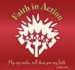](javascript:ClickThumbnail(2))**Caring and Safe Schools:**

There were many examples of **Faith in Action- Make a Difference** throughout the month of December. Many thanks to all who donated food to the St. Vincent de Paul Society as part of the **Jingle Bell Walk**. As well, many families donated items for Gr. 8 student Avery Hull’s collection of needed items for Home Based Housing.

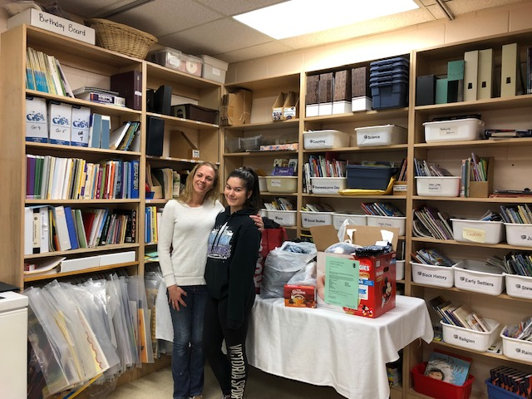

The **Advent Family Evening Mass and Christmas Activities** united our community as well as provided more donations for **St. Vincent de Paul**.

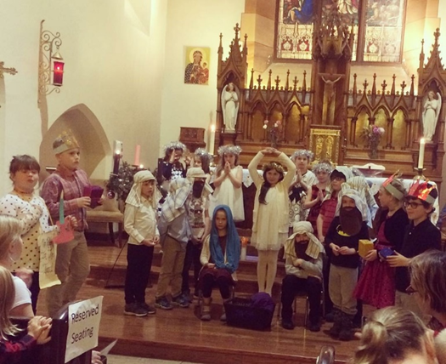

Mrs. Guindon and school volunteer Gayle Woolley organized a **Wilton Cheese Fundraiser** with over $450 raised to go toward extra school supplies (E.g., bussing, sports equipment, special events). So many faith-filled people and actions!

Staff and students said good-bye and wished Madame Alves well on new endeavours, prior to the Christmas holidays. Please welcome Madame Summers to the Holy Name community.

**Weather –***Respect for Self* includes dressing appropriately for winter weather. It is very important that proper clothing is sent and worn. Extra socks and mittens are encouraged.

**Drop off and Pick up:** Thank you to all who keep safety first when dropping off or picking up student(s) near the front entrance. A reminder also that yard supervision does not begin until 9:00 AM. Dismissal is at 3:35 PM; recess is part of the school day and students should not be leaving prior. With your co-operation, we can assure all students are safe and secure.

**School Mass** is scheduled for **Thurs. Jan. 24, 2019** beginning at 9:30 AM at Holy Name of Jesus Church**.** Please join us.

**ECO School Update:**  We encourage all families to follow daily learning and events on Twitter: **@alcdsb_name.** 

**E-Portfolios**: Moving forward with themandatory career/life planning program by the Ministry of Education, parents are encouraged to view and comment on their child/children about their learning using the FreshGrade App regularly. Students and parents should aim to post and respond MORE as a goal for the new year!



**Regiopolis – Notre Dame Catholic High School offers the International Baccalaureate (IB) Program.** The program gives students the opportunity to graduate from high school with both the Ontario Secondary School Diploma and the IB Diploma.  The IB program is intended for highly motivated, university bound students.  It is an appropriate pathway for students who seek opportunities to extend their learning through an enriched and challenging academic program.  More information about IB is available at the following websites: <http://www.ibo.org/> and on the Regiopolis-Notre Dame Catholic  High School website under the Programs/International Baccalaureate tabs.

**Sports Update –** Basketball Board Team Tournaments take place in February: Sr. Boys on Feb. 20th; Sr. Girls on Feb. 21st; Jr. Boys on Feb. 25th, and Jr. Girls on Feb. 26th.  
Thanks for the time and support of this year’s coaches: Mrs. Graham, Ms. Ross, Mr. Gaudet, Mr. Archer, and Mr. Waller.

**Knights of Columbus Basketball Free Throw Competition** is being held on **Fri. Jan. 18/19** beginning at 9:30 AM.

**Family Literacy Week –** Jan. 27 – Feb. 01/19****

Watch for further details on the school’s webpage!

**Catholic School Council Update**

**Minutes** from meetings are posted on the school website once they are available from Council.   
Fundraising Committee Members extend a thanks to all who had family photos taken with Santa and/or participated in the Silent Auction at the Family Social following the Advent Mass. Thanks to the active participation and support, approximately $400 was raised toward the Playground Renewal project.

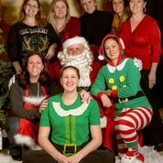

Next Fundraiser being planned is **ChiliFest** on Jan. 31/19! Save the date!

All parents are invited to attend the next School Council meeting scheduled for: **Wed. Jan. 16, 2019 at 6:30 PM.**